Constructor
________________________________________________________________________________
Constructor is a function same name as class name but without return type.

Syntax:

Example:
class A{
A() //constructor
{
}
}
Q. Why use constructor or what is benefit of constructor?
______________________________________________________________________________
There are two benefits of constructor
a) To call logic when we create object of the class: constructor get executed when we create object of the class.
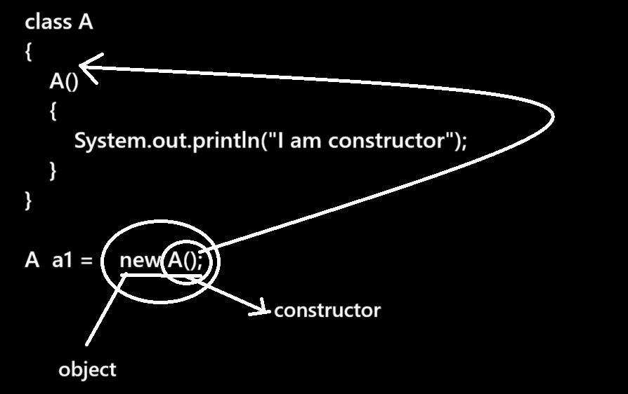
b) To initialize object: normally constructor is used for when we want to initialize the instance variable at the time of object or initialize value to instance variable at the time of object.
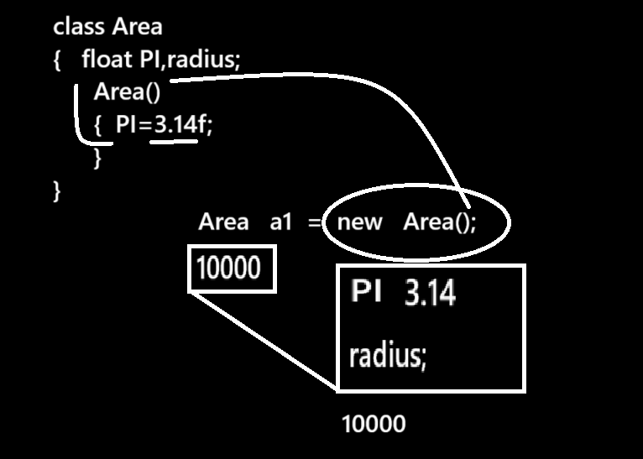
Note: if developer not write constructor in his class then every class has one default constructor known as implicit constructor.

Q. Can we see the implicit constructor?
______________________________________________________________________________
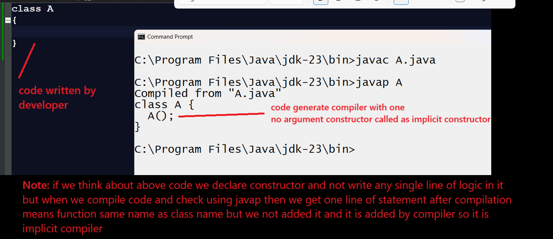
Types of constructor
___________________________________________________________
1. Default constructor: when we declare constructor within class without parameter it called as default constructor.
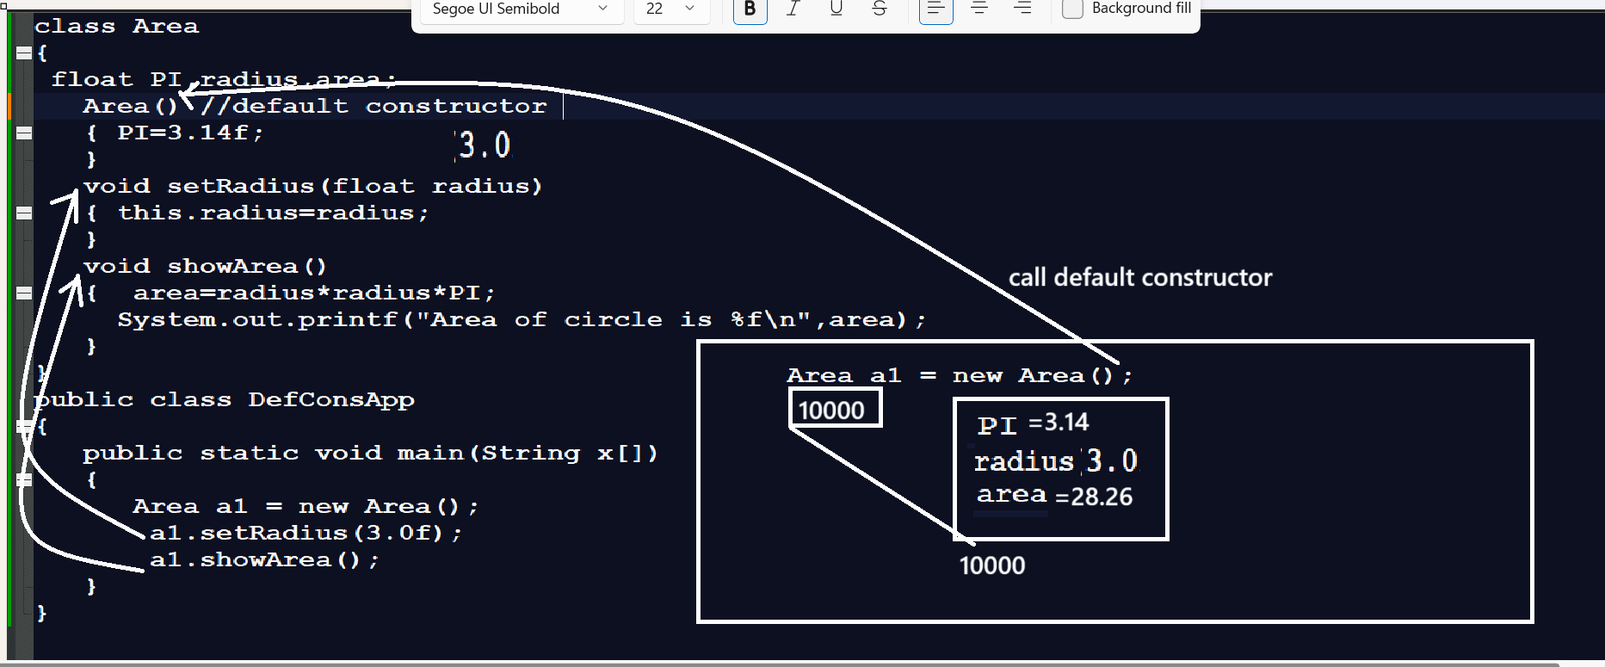

Q. what is difference between default constructor and implicit constructor?
_________________________________________________________________________
default constructor is also non-argumented constructor but define by developer manually in class and which we can see by our eye in code and implicit constructor is also non-argumented constructor but define internally by compiler and compiler only add implicit constructor class when developer not write own constructor.
When developer write own constructor then compiler not added implicit constructor in class.

Q. Why compilers add own constructor in class when developer not added constructor?
___________________________________________________________________________
if we think about of java or any OOP language we cannot create object without constructor calling means if we think about java JVM cannot create object without constructor calling or cannot use new keyword without constructor and when developer add own constructor then JVM call developer constructor with new keyword and create object of class but when developer not added own constructor then JVM may be generate problem at the time of object creation at run time and for this problem compiler check the constructor in class at compilation level if compiler not found constructor in code written by developer then compiler add one default constructor internally called as implicit constructor so this is major reason compiler add implicit constructor in class when developer not added own constructor in class .

2. Parameterized constructor: when we pass parameter to constructor called as parameterized constructor.

Example:
class Value
{
Value(int x)
{
}
}
Note: when we pass parameter to constructor then we need to pass parameter to object or pass parameter at constructor calling point i.e at the time of object creation.
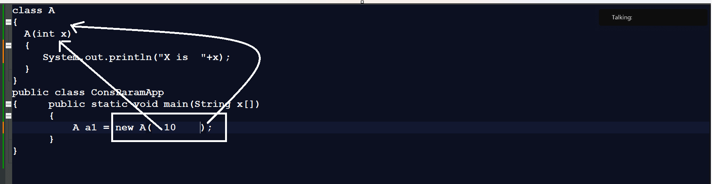

How to pass array as parameter to constructor?
____________________________________________________________________________________
If we want to pass array as parameter to constructor we required to pass base address array to constructor

import java.util.*;
class CA
{ int x[];
CA(int x[])
{this.x=x;
}
void showArr()
{ for(int val:x)
{ System.out.println(val);
}
}
}
public class CAAPP
{ public static void main(String x[])
{ int a[]=new int[5];
Scanner xyz = new Scanner(System.in);
System.out.println("Enter values in array");
for(int i=0; i<a.length;i++)
{ a[i]=xyz.nextInt();
}
CA c=new CA(a); //pass array to constructor
System.out.println("Display array");
c.showArr();
}
}

How to pass POJO object as parameter to class constructor
__________________________________________________________________________
class Book
{
private int id;
private String name;
public void setId(int id)
{ this.id=id;
}
public int getId()
{ return id;
}
public void setName(String name)
{ this.name=name;
}
public String getName()
{ return name;
}
}
class Library
{ Book book;
Library(Book b)
{ book=b;
}
void showBook()
{ System.out.println(book.getId()+"\t"+book.getName());
}
}
public class BookLibApp
{
public static void main(String x[])
{
Book b1 = new Book();
b1.setId(1);
b1.setName("Let us C");
Library l = new Library(b1);
l.showBook();
}
}
or
class Book
{
private int id;
private String name;
public Book(int id,String name)
{ this.id=id;
this.name=name;
}
public void setId(int id)
{ this.id=id;
}
public int getId()
{ return id;
}
public void setName(String name)
{ this.name=name;
}
public String getName()
{ return name;
}
}
class Library
{ Book book;
Library(Book b)
{ book=b;
}
void showBook()
{ System.out.println(book.getId()+"\t"+book.getName());
}
}
public class BookLibApp
{
public static void main(String x[])
{
Book b1 = new Book(1,"Let us C");
Library l = new Library(b1);
l.showBook();
}
}
or
class Book
{
private int id;
private String name;
public Book(int id,String name)
{ this.id=id;
this.name=name;
}
public void setId(int id)
{ this.id=id;
}
public int getId()
{ return id;
}
public void setName(String name)
{ this.name=name;
}
public String getName()
{ return name;
}
}
class Library
{ Book book;
Library(Book b)
{ book=b;
}
void showBook()
{ System.out.println(book.getId()+"\t"+book.getName());
}
}
public class BookLibApp
{
public static void main(String x[])
{
Library l = new Library(new Book(1,"Let us C"));
l.showBook();
}
}
or
class Book
{
private int id;
private String name;
public Book(int id,String name)
{ this.id=id;
this.name=name;
}
public void setId(int id)
{ this.id=id;
}
public int getId()
{ return id;
}
public void setName(String name)
{ this.name=name;
}
public String getName()
{ return name;
}
}
class Library
{ Book book;
Library(Book b)
{ book=b;
}
void showBook()
{ System.out.println(book.getId()+"\t"+book.getName());
}
}
public class BookLibApp
{
public static void main(String x[])
{ new Library(new Book(1,"Let us C")).showBook();
}
}
3. Overloaded constructor
_____________________________________________________________________
Constructor overloading means when we have same constructor name with different parameter list with different parameter sequence with a different data type called as constructor overloading.
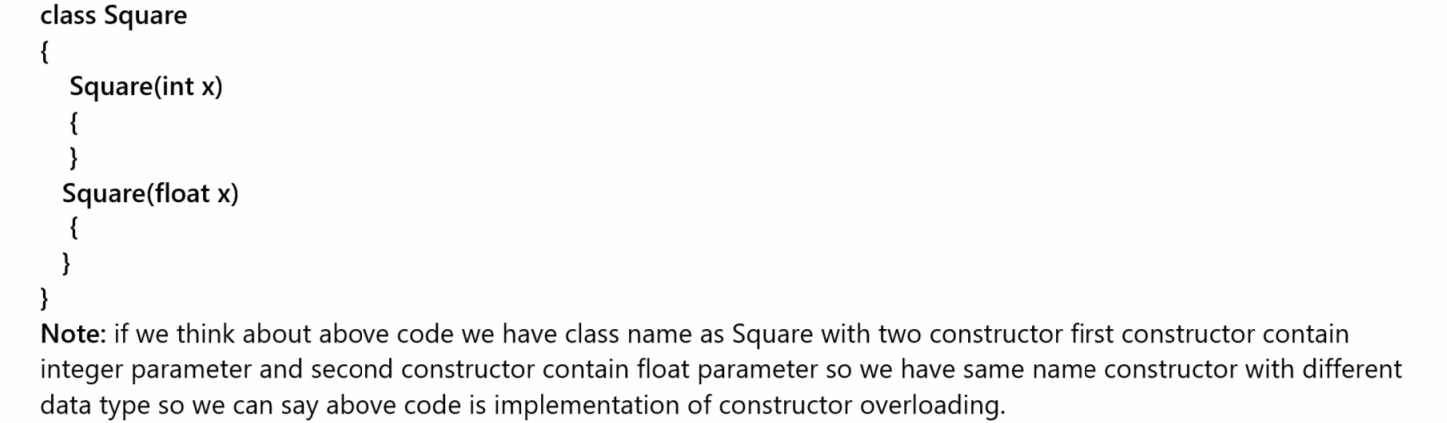
Note: if we think about constructor overloading which constructor should execute is dependent on number of parameter in it , its data type and its sequence
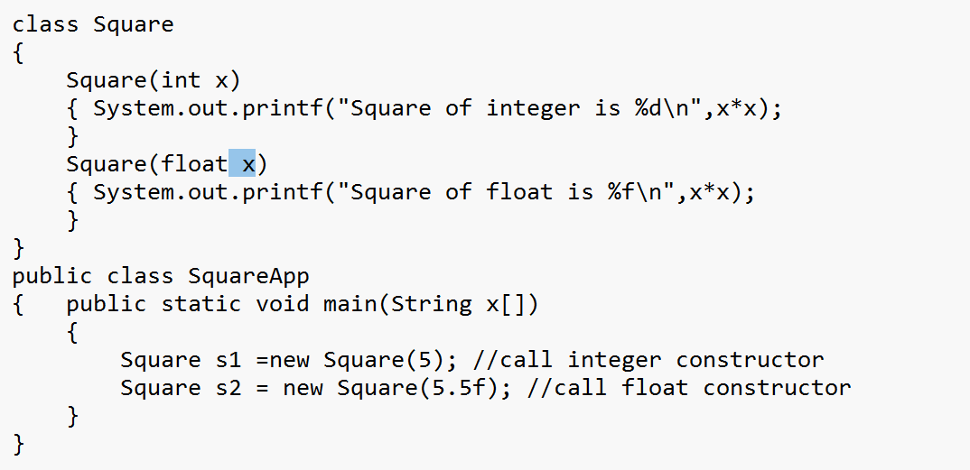

Example of constructor overloading
___________________________________________________________________________
class Doctor
{
private int id;
private String name;
private String degree;
private int exp;

public void setId(int id)
{ this.id=id;
}
public int getId()
{ return id;
}
public void setName(String name)
{ this.name=name;
}
public String getName()
{ return name;
}
public void setDegree(String degree)
{ this.degree=degree;
}
public String getDegree()
{ return degree;
}
public void setExp(int exp)
{ this.exp=exp;
}
public int getExp()
{ return exp;
}
}
class Equipment
{
private int id;
private String name;
public void setId(int id)
{ this.id=id;
}
public int getId()
{ return id;
}
public void setName(String name)
{ this.name=name;
}
public String getName()
{ return name;
}
}
class Hospital
{ Hospital(Doctor d)
{ System.out.println(d.getId()+"\t"+d.getName()+"\t"+d.getDegree()+"\t"+d.getExp());
}
Hospital(Equipment e)
{ System.out.println(e.getId()+"\t"+e.getName());
}
}
public class HospitalApp
{ public static void main(String x[])
{
Doctor d = new Doctor();
d.setId(1);
d.setName("ABC");
d.setDegree("MD");
d.setExp(20);

Equipment e = new Equipment();
e.setId(1);
e.setName("XYZ");
System.out.println("Doctor detail is ");
System.out.println("=====================================");
Hospital h1 = new Hospital(d);
System.out.println("Equipment Details is ");
System.out.println("===========================================");
Hospital h2 = new Hospital(e);
}
}
or
class Doctor
{
private int id;
private String name;
private String degree;
private int exp;

Doctor(){
}
Doctor(int id,String name,String degree,int exp)
{ this.id=id;
this.name=name;
this.degree=degree;
this.exp=exp;
}
public void setId(int id)
{ this.id=id;
}
public int getId()
{ return id;
}
public void setName(String name)
{ this.name=name;
}
public String getName()
{ return name;
}
public void setDegree(String degree)
{ this.degree=degree;
}
public String getDegree()
{ return degree;
}
public void setExp(int exp)
{ this.exp=exp;
}
public int getExp()
{ return exp;
}
}
class Equipment
{
private int id;
private String name;

Equipment(){
}
Equipment(int id,String name)
{ this.id=id;
this.name=name;
}
public void setId(int id)
{ this.id=id;
}
public int getId()
{ return id;
}
public void setName(String name)
{ this.name=name;
}
public String getName()
{ return name;
}
}
class Hospital
{ Hospital(Doctor d)
{ System.out.println(d.getId()+"\t"+d.getName()+"\t"+d.getDegree()+"\t"+d.getExp());
}
Hospital(Equipment e)
{ System.out.println(e.getId()+"\t"+e.getName());
}
}
public class HospitalApp
{ public static void main(String x[])
{
Doctor d = new Doctor(1,"ABC","MD",15);
Equipment e = new Equipment(1,"XYZ");
System.out.println("Doctor detail is ");
System.out.println("=====================================");
Hospital h1 = new Hospital(d);
System.out.println("Equipment Details is ");
System.out.println("===========================================");
Hospital h2 = new Hospital(e);
}
}

or
class Doctor
{
private int id;
private String name;
private String degree;
private int exp;

Doctor(){
}
Doctor(int id,String name,String degree,int exp)
{ this.id=id;
this.name=name;
this.degree=degree;
this.exp=exp;
}
public void setId(int id)
{ this.id=id;
}
public int getId()
{ return id;
}
public void setName(String name)
{ this.name=name;
}
public String getName()
{ return name;
}
public void setDegree(String degree)
{ this.degree=degree;
}
public String getDegree()
{ return degree;
}
public void setExp(int exp)
{ this.exp=exp;
}
public int getExp()
{ return exp;
}
}
class Equipment
{
private int id;
private String name;

Equipment(){
}
Equipment(int id,String name)
{ this.id=id;
this.name=name;
}
public void setId(int id)
{ this.id=id;
}
public int getId()
{ return id;
}
public void setName(String name)
{ this.name=name;
}
public String getName()
{ return name;
}
}
class Hospital
{ Hospital(Doctor d)
{ System.out.println(d.getId()+"\t"+d.getName()+"\t"+d.getDegree()+"\t"+d.getExp());
}
Hospital(Equipment e)
{ System.out.println(e.getId()+"\t"+e.getName());
}
}
public class HospitalApp
{ public static void main(String x[])
{ System.out.println("Doctor detail is ");
System.out.println("=====================================");
Hospital h1 = new Hospital(new Doctor(1,"ABC","MD",15));
System.out.println("Equipment Details is ");
System.out.println("===========================================");
Hospital h2 = new Hospital(new Equipment(1,"XYZ"));
}
}

4. this() constructor
________________________________________________________________________
this() constructor is used for perform constructor chaining using java

Q. What is constructor chaining?
__________________________________________________________________
Constructor chaining means we can call one constructor from another constructor without creating object of class called as constructor chaining.

There are two ways to perform constructor chaining in JAVA?
________________________________________________________________________
1. Using this() constructor
2. Using super() constructor: if we think about super() constructor we will discuss in inheritance chapter.

Now we want to discuss about this() constructor?
_________________________________________________________________________
this() constructor can perform constructor chaining using constructor overloading technique.
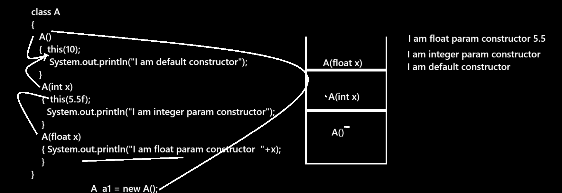
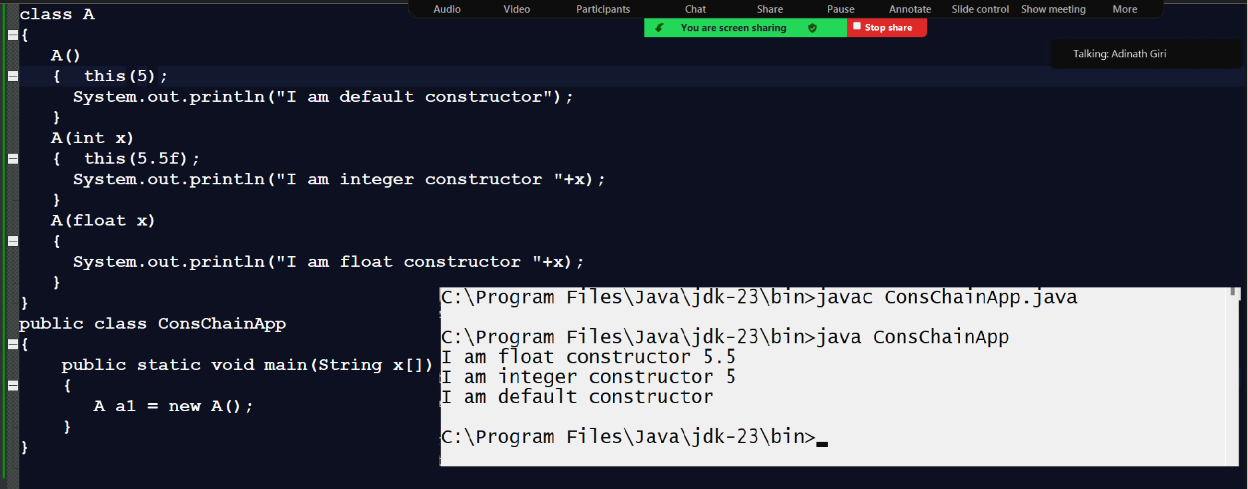
Note: this() constructor must be first line of in calling constructor

If we want to work with constructor we have some important points.

1. Constructor cannot have return type.
__________________________________________________________________________
Note: if we give return type to constructor then java consider it as method means we can say in java method name and constructor name may be same
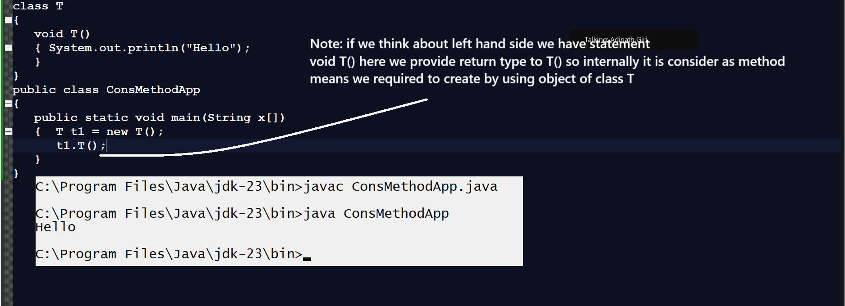

2. Normally try to avoid writing constructor or declaring constructor as private
_________________________________________________________________________________
When we declare constructor as private then there is possibility we cannot create object of class outside of his definition or outside of class body or block.
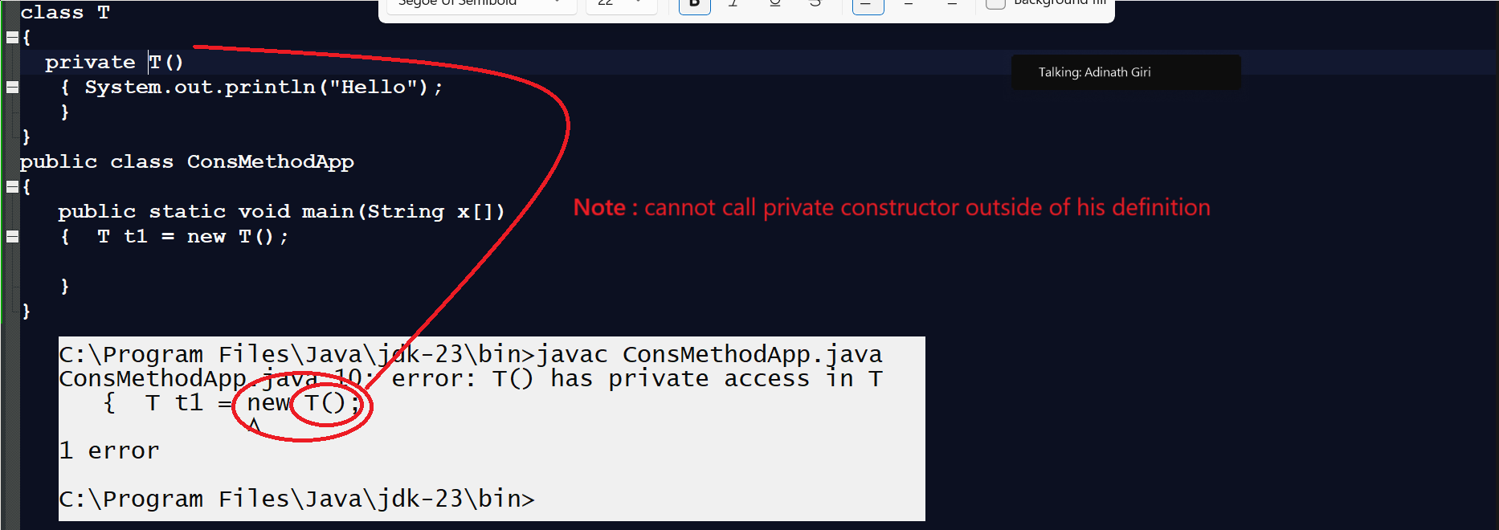
Note: when we want to create
Utility class or Singleton class using Java Then class constructor must be private.

Q. What is utility class?
_________________________________________________________________________
Utility class means class cannot be instantiated and it contain only static method and which is used for perform some regular operation or writing logics in application.
Steps to create Utility class in JAVA
____________________________________________________________________
1. Declare class constructor as private
2. Define static which should access outside of class using classname


Q. What is singleton class?
________________________________________________________________________________
Singleton class means class can create only one object in whole application.

Steps to create Singleton class
________________________________________________________________________________
1. Declare class with private constructor
class DB
{
private DB(){
write here logics
}
}
2. Declare same class reference in it with private static
class DB
{ private static DB db=null;
private DB(){
write here logics
}
}

3. Create one static method and return same class reference from it.

class DB
{ private static DB db=null;
private DB(){
write here logics
}
public static DB getInstance(){
if(db==null)
{ db = new DB();
}
return db;
}
}

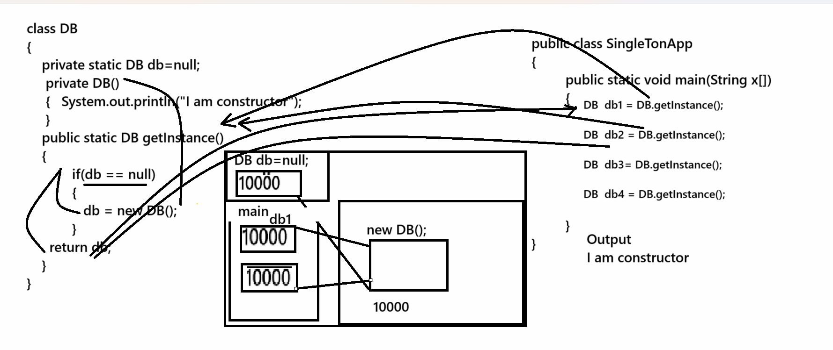

Example with source code
class DB
{ private static DB db=null;
private DB()
{ System.out.println("I am constructor");
}
public static DB getInstance()
{
if(db==null)
{ db = new DB();
System.out.println("Hashcode of db "+System.identityHashCode(db));
}
return db;
}
}
public class DBAPP
{
public static void main(String x[])
{
DB db1 = DB.getInstance();
System.out.println("Hashcode of db1 "+System.identityHashCode(db1));

DB db2 = DB.getInstance();
System.out.println("Hashcode of db2 "+System.identityHashCode(db2));

DB db3 = DB.getInstance();
System.out.println("Hashcode of db3"+System.identityHashCode(db3));

}
}

Q. Can we declare constructor as static?
________________________________________________________________________
No we cannot declare constructor as static Because static member can allocate memory before creating object of class and constructor cannot call without object or can call at the time of object creation so this is major we cannot declare constructor as static and if we try to mark constructor as static then we get compile time error.
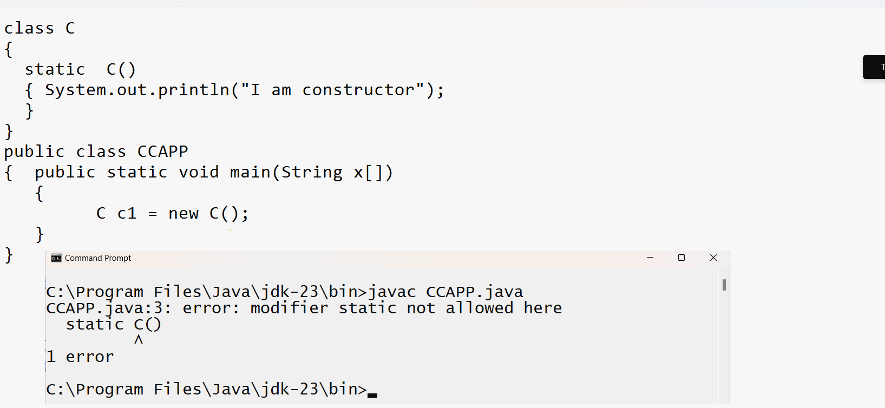

Q. Can we declare constructor as final?
______________________________________________________________________________
No we cannot declare constructor as final because final keyword is used for avoid method overriding if we think about method block and constructor cannot override so declaring final with constructor is useless or meaningless and if we try to declare constructor as final we get compile time error.

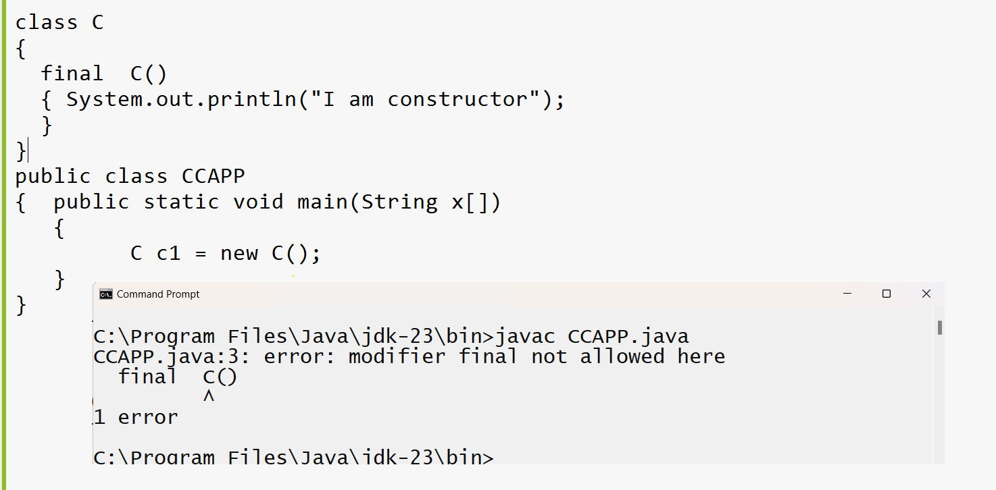

Q. Can we declare constructor as abstract?
___________________________________________________________________
No we cannot declare constructor as abstract because abstract keyword can work with overriding concept and use for achieve dynamic polymorphism but constructor not support to overriding and dynamic polymorphism also so we can say we cannot declare constructor as abstract
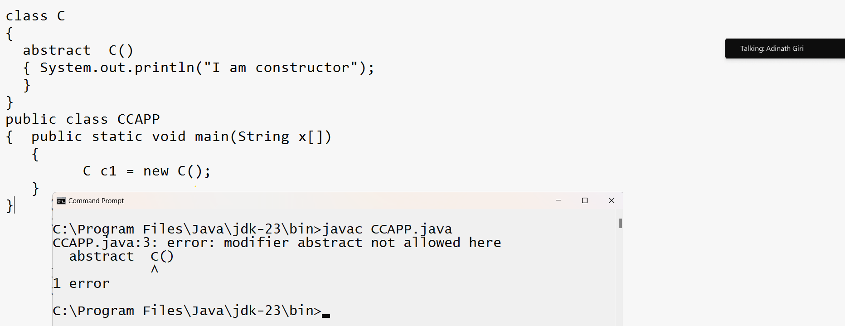

Q. Can we declare constructor as protected?
__________________________________________________________________________
Yes we can declare it as protected
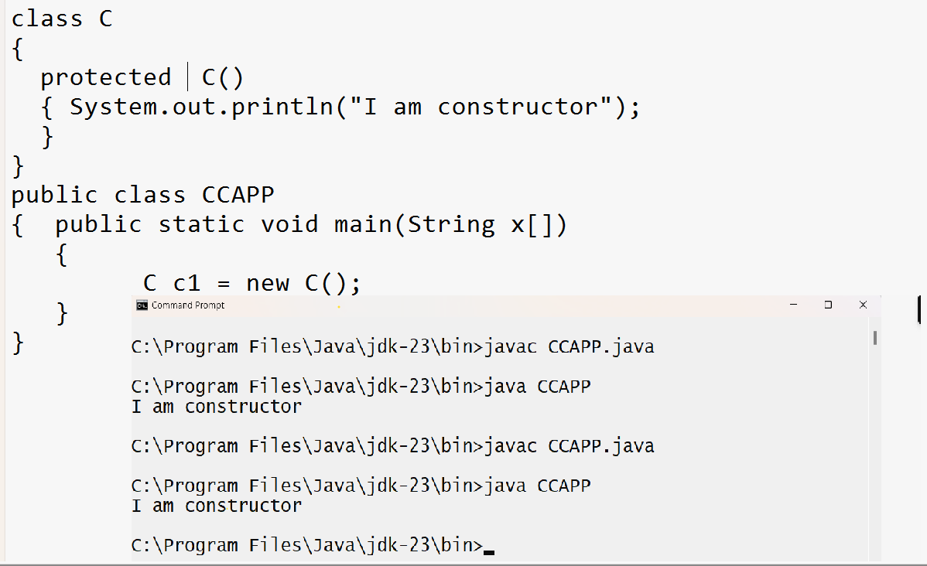
Q. What is difference between constructor and function?
_________________________________________________________________________________
Constructor | Function
Construct name and class must be same without return type | Function name and class name may be same but with return type
Constructor call automatically when we create object of class | Method need to call by object manually or with reference manually
Constructor Is used for initialize object data | Method is used for writing some logics
Constructor cannot declare as static | Method can declare as static
Constructor cannot declare as final | Method can declare as final
Constructor cannot declare as abstract | Method can declare as abstract
Constructor cannot support to overriding | Method can support to overriding
Every class has implicit constructor | But there is no implicit method in class
Constructor cannot support to recursion | Method can support to recursion

